What is Azure Databricks?
Azure Databricks is a cloud-based data analytics platform developed through a partnership between Microsoft Azure and Databricks. It is built on Apache Spark and is designed for large-scale data processing, data engineering, data science, machine learning, and business analytics.
Azure Databricks provides a collaborative environment where data engineers, data scientists, and analysts can work together using notebooks, dashboards, and automated workflows.
Key Features
- Apache Spark-based processing for handling large datasets.
- Interactive notebooks supporting Python, SQL, Scala, and R.
- Auto-scaling clusters to manage computing resources efficiently.
- Integration with Azure services such as Azure Data Lake Storage, Azure Synapse Analytics, Azure Machine Learning, and Azure Blob Storage.
- Collaborative workspace where teams can share notebooks and projects.
- Built-in security and governance through Azure Active Directory integration.
Architecture Overview
- Data is stored in Azure Data Lake or other storage services.
- Azure Databricks reads and processes the data using Spark clusters.
- Data transformations and analytics are performed.
- Results are stored back into databases, data lakes, or visualization tools such as Power BI.
Use Cases
- Big Data Processing
- ETL (Extract, Transform, Load)
- Data Warehousing
- Machine Learning
- Real-Time Analytics
- Business Intelligence Reporting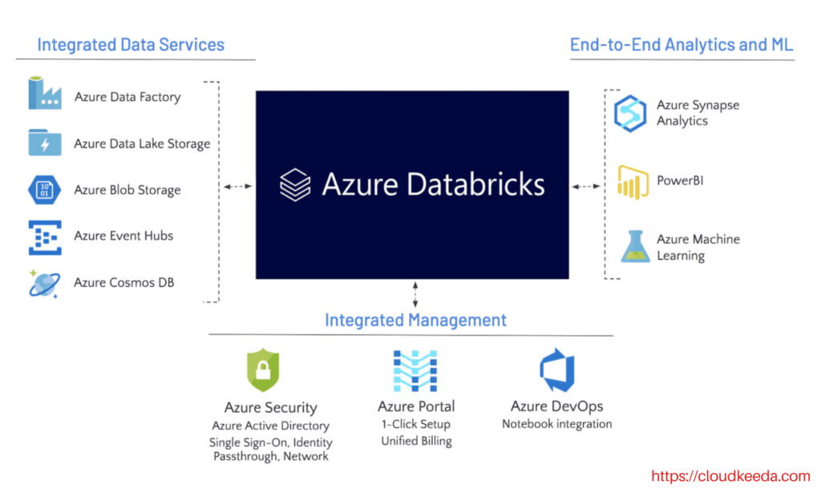

Difference Between Azure Databricks and PySpark
Although Azure Databricks and PySpark are closely related, they are not the same.
What is PySpark?
PySpark is the Python API for Apache Spark. It allows developers to write Spark applications using Python for processing large volumes of data. PySpark provides functionalities such as data transformation, data analysis, machine learning, and streaming.
For example, a developer can use PySpark code to read data, filter records, perform aggregations, and build machine learning models.
What is Azure Databricks?
Azure Databricks is a fully managed cloud platform built on Apache Spark and hosted on Microsoft Azure. It provides an environment where users can develop, run, and manage Spark applications without worrying about cluster setup, infrastructure management, or resource allocation.
Azure Databricks includes additional features such as collaborative notebooks, automated cluster management, security integration, job scheduling, and monitoring tools.

Key Differences
1. Nature
- PySpark is a programming framework/API used to write Spark applications in Python.
- Azure Databricks is a cloud-based platform that provides a managed environment for running Spark workloads.
2. Infrastructure Management
- When using PySpark alone, users typically need to install and configure Apache Spark clusters manually.
- Azure Databricks automatically provisions, manages, and scales Spark clusters.
3. Collaboration
- PySpark itself does not provide collaboration features.
- Azure Databricks offers shared notebooks where multiple team members can work together in real time.
4. Cluster Management
- In a PySpark environment, cluster creation and maintenance are handled by users or administrators.
- Azure Databricks provides automated cluster creation, scaling, and termination.
5. Security
- PySpark security depends on the underlying Spark environment.
- Azure Databricks integrates with Azure Active Directory and provides enterprise-level security features.
6. Monitoring and Job Scheduling
- PySpark requires additional tools for monitoring and scheduling jobs.
- Azure Databricks includes built-in monitoring, job scheduling, and performance tracking.
7. Language Support
- PySpark supports Python for Spark programming.
- Azure Databricks supports Python, SQL, Scala, and R within the same workspace.

What Are the Advantages of Using Azure Databricks?
Azure Databricks offers several advantages for organizations handling large-scale data workloads.
1. High Performance
- Built on Apache Spark.
- Processes large volumes of data quickly.
- Optimized execution engine improves performance.
2. Easy Cluster Management
- Automatically creates and manages clusters.
- Supports auto-scaling based on workload demand.
3. Collaborative Environment
- Multiple users can work on the same notebook.
- Easy sharing of code, results, and dashboards.
4. Seamless Azure Integration
Works with:
- Azure Data Lake Storage
- Azure Blob Storage
- Azure Synapse Analytics
- Azure Machine Learning
- Power BI
5. Multiple Language Support
Developers can use:
- Python
- SQL
- Scala
- R
6. Enhanced Security
- Azure Active Directory authentication.
- Role-Based Access Control (RBAC).
- Data encryption and network security.
7. Machine Learning Support
- Built-in ML libraries.
- MLflow integration for model tracking.
- Supports end-to-end machine learning workflows.
8. Cost Optimization
- Pay only for resources used.
- Auto-termination of idle clusters reduces costs.
9. Real-Time Processing
Supports:
- Streaming analytics
- IoT data processing
- Real-time monitoring systems
10. Faster Development
- Interactive notebooks.
- Reusable code.
- Easy debugging and testing.

What is a Workspace?
A Workspace in Azure Databricks is the central environment where users create, organize, manage, and collaborate on Databricks resources.
Think of a workspace as a project area where teams store notebooks, libraries, dashboards, and other development assets.
Components of a Workspace
Notebooks
Interactive documents containing:
- Code
- Visualizations
- Documentation
Clusters
Computing resources used to execute Spark jobs.
Libraries
Reusable packages and dependencies.
Repositories (Repos)
Version-controlled code integrated with Git.
Dashboards
Visual reports and analytics.
Benefits of a Workspace
- Centralized project management.
- Team collaboration.
- Secure access control.
- Easy sharing of resources.
- Organized development environment.
Example
A retail company may have one Databricks workspace where:
- Data Engineers build ETL pipelines.
- Data Scientists train machine learning models.
- Analysts create reports and dashboards.
All users collaborate within the same workspace.

What is EDA (Exploratory Data Analysis)?
Exploratory Data Analysis (EDA) is the process of examining, summarizing, and visualizing data to understand its characteristics before performing advanced analytics or machine learning.
The primary goal of EDA is to discover patterns, identify anomalies, detect relationships, and understand the structure of the data.
Objectives of EDA
- Understand data distribution.
- Detect missing values.
- Identify outliers.
- Discover trends and patterns.
- Check data quality.
- Generate hypotheses for further analysis.
Steps in EDA
1. Data Collection
Gather data from various sources.
2. Data Cleaning
- Remove duplicates.
- Handle missing values.
- Correct inconsistencies.
3. Data Exploration
Calculate:
- Mean
- Median
- Mode
- Standard Deviation
4. Data Visualization
Use:
- Histograms
- Bar Charts
- Pie Charts
- Scatter Plots
- Box Plots
5. Feature Analysis
Study relationships among variables.
Example
Student dataset:
Student | Marks
A | 85
B | 90
C | 78
D | 95
EDA in Azure Databricks
Databricks provides powerful tools for EDA:
- SQL queries
- PySpark DataFrames
- Visualization charts
- Notebook-based analysis
Example:
df.describe().show()
Benefits of EDA
- Improves data quality.
- Helps select suitable machine learning algorithms.
- Identifies issues before model training.
- Leads to better business insights.
- Reduces chances of inaccurate analysis.

